上机实验7：尝试编写一个程序，实现两个复数的乘法

#include<iostream>

using namespace std;

class Complex {

public:

double real;

double image;

Complex(double r = 0, double i = 0) {

real = r;

image = i;

}

};

Complex operator*(Complex co1, Complex co2) {

Complex temp;

temp.real = co1.real * co2.real - co1.image * co2.image;

temp.image = co1.real * co2.image + co1.image * co2.real;

return temp;

}

int main() {

Complex com1(2.3, 3.5), com2(3.1, 4.2), total1, total2;

total1 = operator*(com1, com2)；

cout << "real1=" << total1.real <<" " << "image1=" << total1.image << endl;

total2 = com1 * com2;

cout << "real2=" << total2.real << " " << "image2=" << total2.image << endl;

return 0;

}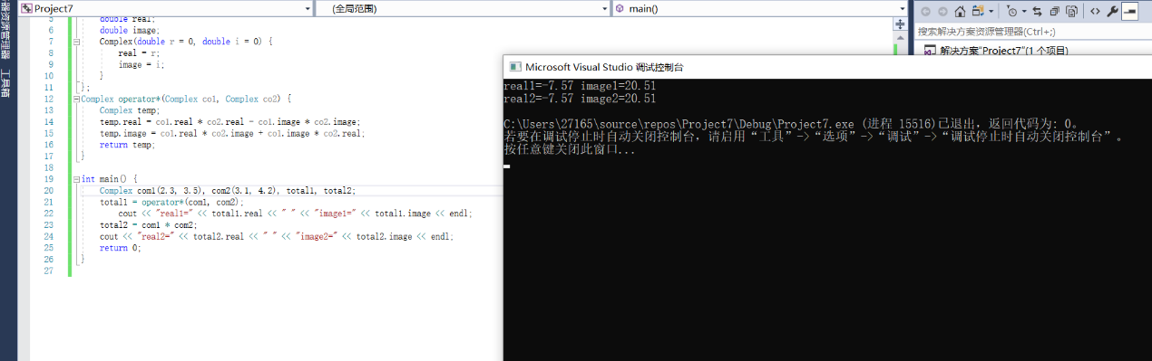

**收获：通过课本上的复数的加法来作参考，写出了复数的乘法。学习到了第五章的operator类外定义运算符，加深了其中的印象，受益匪浅。**

Copyright ©2021-2099 王翰扬. All rights reserved